|  |  |
| --- | --- |
| **Intermediate Scale Testing**  **Recommendation Report** | |
|  |
|  |
|  |
| ***Prepared for***  ***U.S. Department of Energy***  ***Used Fuel Disposition***  Frank Hansen and Steve Sobolik,  Sandia National Laboratories  Phil Stauffer, Los Alamos National Laboratory    ***September 30, 2016***  ***FCRD-UFD-2016- 000030 Rev. 0***  ***SAND2016-XXXX*** |

**Disclaimer**

This information was prepared as an account of work sponsored by an agency of the U.S. Government. Neither the u.s. government nor any agency thereof, nor any of their employees, makes any warranty, expressed or implied, or assumes any legal liability or responsibility for the accuracy, completeness, or usefulness, of any information, apparatus, product, or process disclosed, or represents that its use would not infringe privately owned rights. References herein to any specific commercial product, process, or service by trade name, trade mark, manufacturer, or otherwise, does not necessarily constitute or imply its endorsement, recommendation, or favoring by the U.S. Government or any agency thereof. The views and opinions of authors expressed herein do not necessarily state or reflect those of the U.S. government or any agency thereof.



Sandia National Laboratories is a multi-mission laboratory managed and operated by Sandia Corporation, a wholly owned subsidiary of Lockheed Martin Corporation, for the U.S. Department of Energy’s National Nuclear Security Administration under contract DE-AC04-94AL85000.

Approved for Unclassified Unlimited Release

SUMMARY

A summary of recommendations for near-term intermediate-scale testing pertaining to a salt repository is provided in this report. Each proposal implements a phased progression, initiating with Test Plan production in FY 2017 and early-stage testing, if possible. Beyond 2017, testing is anticipated to progress to an underground setting and involve intermediate-scale field activities.

**More to be added after Phil Stauffer looks over this current version.**

ACKNOWLEDGEMENTS

Laura Connolly, as always, deserves credit for organizing this document into Used Fuel Disposition format and ensuring professional readability and aesthetics. The authors thank the Department of Energy Nuclear Energy (DOE-NE) staff, particularly Prasad Nair, for arranging the June 6th meeting and orchestrating the technical exchanges. The purpose to this deliverable is to account formally of the discussions and provide summaries of the three main testing regimes explored. The essence of this report has an assortment of source documents. The text here often draws directly from previously issued documents and updates material according to the requests of DOE NE. To avoid misrepresenting work of colleagues, Phil Stauffer of Los Alamos National Laboratory edited sections of this report deriving from presentations he made at the June 6th meeting. Phil is included as a co-author for this contribution. Much of the material presented on shear testing was developed by Steve Sobolik of Sandia National Laboratories and he is therefore included as a co-author. In addition, this document was reviewed by Robert J. Mackinnon and Kris Kuhlman of Sandia.

Content of this document is intended to be used for planning FY17 intermediate-scale salt testing pertinent to disposal of nuclear waste in salt repositories. A projection of continuation into out-year activities is made. In all cases, the work will be developed and formalized in Test Plans following appropriate Quality Assurance procedures. The content of this Level IV Milestone meets the requirements of M4FT-16SN0803090321 *Intermediate Scale Testing Recommendation Report* and is intended to guide decisions regarding future testing regimes. Content made available here represents the state of affairs on June 6th 2016 and remains a work in progress. The authors endeavored to capture information fairly and attribute sources correctly. Remaining inconsistencies are thought to be minor in nature and would be trued up as Test Plans are developed for implementation of the selected activities.

TABLE OF CONTENTS

SUMMARY iii

ACKNOWLEDGEMENTS iv

TABLE OF CONTENTS v

LIST OF FIGURES v

LIST OF TABLES v

ACRONYMS vi

1 INTRODUCTION 1

2 SMALL-DIAMETER BOREHOLE THERMAL TEST 1

3 GRANULAR SALT RECONSOLIDATION 7

3.1 Brief Overview 7

3.2 Discussion 11

3.3 Underground Testing 14

4 SHEAR TESTING 15

5 CONCLUDING REMARKS 19

6 REFERENCES 20

LIST OF FIGURES

Figure 2‑1. Schematic of small-diameter borehole thermal test. 6

Figure 2‑2. Test Schedule. 7

Figure 3‑1. Triaxial test apparatus for scoping experiments. 9

Figure 3‑2. Commercial jack system with integrated reaction frame. 10

Figure 3‑3. Field-scale reconsolidation of granular salt. 10

Figure 3‑4. Permeability-porosity datasets for crushed salt and mixtures. 12

Figure 4‑1. Direct shear test setup; Shear stress vs. displacement for different shear velocities (Photograph of MTS direct shear machine from MTS website). 16

Figure 4‑2. Conceptual design of *in situ* test alcove, with flatjack locations. 17

Figure 4‑3. Isolated test pillar 18

Figure 4‑4. Pressurized flatjack instrumented with rotating potentiometer. 18

LIST OF TABLES

Table 3‑1. Nominal mixtures for Laboratory scoping tests 9

ACRONYMS

BAMBUS Backfilling and Sealing of Underground Repositories for Radioactive Waste in Salt

DOE Department of Energy

DRZ Disturbed Rock Zone

EM Environmental Management

HCl Hydrogen Chloride (hydrogen chloride gas and hydrochloric acid, the aqueous solution of hydrogen chloride, are given the formula HCl)

LANL Los Alamos National Laboratory

LBNL Lawrence Berkeley National Laboratory

LVDT Linear Variable Differential Transformer

NE Nuclear Energy

QA Quality Assurance

R&D Research and Development

RoM Run-of-Mine

SNL Sandia National Laboratories

THMC Thermal-Hydrologic-Mechanical-Chemical

URF Underground Research Facility

US United States

WIPP Waste Isolation Pilot Plant

# INTRODUCTION

This report summarizes three proposals for intermediate-scale testing in salt. Information derives from a special meeting held on June 6, 2016, at the Department of Energy Nuclear Energy (DOE NE) Offices in Las Vegas. Representatives from DOE NE, DOE Environmental Management (EM), Los Alamos, Sandia and Lawrence Berkeley National Laboratories (LANL, SNL, and LBNL) outlined prospective tests by providing overviews, descriptions, justification, and rough estimates of budget and schedules.

A primary goal for the June 6th meeting, as expressed by DOE, was to examine test concepts possessing scalable attributes lending themselves to transferability from the surface to an underground research facility (URF), if a URF were to become available. Timing was also a significant element of viability because DOE desired demonstrated progress in FY2017. Overall Test Plan development, reconnaissance surface testing, and preparations for transfer to the underground were to be undertaken in FY2017 as a planning basis. Guidelines for discussion emphasized forethought regarding the amount of prospective testing that could be accomplished in FY2017 and how a foundation might be established for continuing the proposed experiments in an underground setting.

For purposes of discussion, the location of the underground test field was not a governing factor. The site could be at the Waste Isolation Pilot Plant (WIPP), which continues recovery activities since shutdown in February 2014, an alternative salt mine in the United States (US), or a site in Germany.

There is no operating URF for salt repository research in the US or in Germany. Further, there is no identified technical shortcoming that requires extensive field testing before developing a safety case for a high-level waste repository in salt. These circumstances afford an opportunity for dispassionate reflection upon possible field activities outside of political and fiscal pressure to consider what priorities for advancing the technical basis for salt disposal might be if a salt URF were to be made available.

Three testing concepts developed and discussed in considerable detail and will be the primary focus of this deliverable. Namely,

1. Small-diameter borehole field test,
2. Shear strength and deformation along discontinuities, and
3. Reconsolidation of granular salt.

The remainder of this document is divided into Sections dedicated to each of these proposed testing ideas.

# SMALL-DIAMETER BOREHOLE THERMAL TEST

Testing described in this section is characterized as a ***small-diameter borehole thermal test***. In previous iterations, such as described in Sevougian et al. (2013) and elsewhere, a generic test with similar parameters was called a***standardized single-heater test***. Generically, the test is presumed to be relatively low cost and performed at a small spatial scale. Such a test could be used to develop instrumentation and methods for further *in situ* testing, demonstrations, and characterization activities. A single-heater test could be used to assess changes in physical-chemical properties associated with potential brine and vapor liberation and migration at elevated temperature. International collaborations addressing model prediction and validation could also be part of a single-heater test.

At the June 6th meeting a phased field-test campaign starting in FY 17 was proposed that would begin with a small-diameter borehole thermal test and, pending the outcome and available funding, proceed to single full-size heated canister to be emplaced in a larger borehole. These sequential tests and the benefits of implementing them in a staged approach are outlined in Stauffer et al. (201*5*) report: *Test Proposal Document for Phased Field Thermal Testing in Salt*. Based on deliberations in the June 6th meeting, if annual NE funding for salt Research and Development (R&D) remains approximately at the current level in FY 17 and beyond, a small-diameter borehole test could be completed in approximately 5 years. A draft summary of the small-diameter borehole thermal test provided subsequently draws from several previous iterations of field test discussions (Sevougian et al. 2013, Stauffer et al. 2015, and Hansen et al. 2015). As a planning basis, the Test Plan would be developed in FY17 collectively by LANL, LBNL, and SNL.

Details of final experiment would be compiled in a Test Plan in accord with prevailing Quality Assurance (QA) requirements. As an example, Nuclear Waste Management Procedures can be accessed online https://nwmp.sandia.gov/onlinedocuments/np-ext.htm. Technical contributors associated with NE Salt R&D have sufficient QA experience with participation in WIPP, Yucca Mountain and the Used Fuel Campaign itself to grasp requirements of Test Plans, which are written to ensure that a scientific activity is accomplished under suitable controlled conditions. Test Plans are approved prior to initiation of work and describe the scientific activity in sufficient detail to allow the test or experiment to be conducted.

Prerequisite testing and modeling may be deemed necessary before a Test Plan can be developed. In these instances, Work Packages for FY 17 will describe such scope and deliverables. Laboratory testing and modeling activities at LANL, LBNL, and SNL in FY17 would be intended to support specific aspects of the development of a Test Plan for the small-diameter borehole thermal test.

At the June 6th meeting, a previous concept for a ***single canister thermal test*** was discussed in the context of instrumentation and monitoring capability at elevated temperature because similar capabilities would apply to small-diameter borehole thermal test. The overall concept of a single canister demonstration was not deemed consistent with the expectations and guidance from DOE-NE for the June 6th meeting. Therefore, the proposal to develop a Test Plan for small-diameter borehole testing became a focal point. However, a draft scope of work to support a generic single canister thermal test was discussed during the June 6th meeting and for completeness of this report a summary is included in Appendix A.

The last thermal tests in salt in the US involving full-sized canisters were performed more than 20 years ago. Computational capabilities used to predict long-term performance have increased significantly in this time. Processes including evaporation/condensation, water accentuated compaction, mineral dehydration, and acid gas generation have been recognized as potentially important for long term safety considerations and have been added to some numerical simulators.

Brine and gas processes may have increased importance in bedded salt because on average it contains more available brine than domal salt at typical repository depths (Hansen and Leigh, 2011). Testing in domal salt may not experience effects of all brine-sensitive processes, including understanding the behavior of brine in generic salt systems that are subjected to heating. Other information that factors into the proposed testing includes: (1) recent research results on mineralogical and chemical considerations (Stauffer et al. 2015), (2) focused discussions with DOE NE concerning test planning, and (3) ongoing studies and associated reports concerning US and international recommendations related to the safety case and engineering performance (e.g., Hansen et al. 2014; 2015; Rudqvist 2015).

Thermally driven changes for common minerals in salt deposits that may be relevant to the safety case are: (1) generation of hydrogen chloride (HCl) vapors (Krumhansl et al. 1991) from reaction of magnesium chloride salts (e.g., MgCl2 4H2O), and (2) dehydration of clays (and other phases), which begins at temperatures as low as 75oC (Caporuscio et al. 2013). Although these minerals tend to be minor in salt deposits, Caporuscio et al. (2013) suggest variable distribution may have effects on geochemical conditions potentially relevant to repository performance. Systematic study of hydrous minerals that are commonly found in bedded salt deposits has been initiated in the laboratory (LANL 2013-2015); however, *in situ* impacts of mineral dehydration and acid gas generation have not been studied.

Borehole scale tests have recently been proposed as part of both US and US/German reviews. Examples include Kuhlman and Malama (2013), Stauffer et al. (2015), and Hansen et al. (2016). In fact, two of the nine proposed tests of the 6th US/German Workshop on Salt Repository Research, Design, and Operation (Hansen et al. 2016) are based on borehole scale experiments testing borehole seals and brine availability. Kuhlman and Malama (2013) propose two similar borehole scale tests to measure brine inflow and brine characterization using geophysical methods. Because borehole tests can be relatively simple, they are expected to be modest in cost. The LANL presentation on borehole field thermal testing envisioned several small tests could be performed over a 2-year period, with different designs to address different questions. For example, a thermomechanical salt test would likely involve a heater installed in contact with the salt to ensure accelerated coupling of deformational processes. For an HCl-generation experiment, a packer or plug system could be used to isolate a heater packed with Run-of-Mine (RoM) salt of varying degrees of hydrous mineral content.

LANL proposed to collaborate with SNL and LBNL on a series of small-diameter borehole field thermal tests. These tests will be similar to those described in Stauffer et al. (2015). This work would be a first step to restarting US field testing in salt. These tests can be used to isolate phenomena in a simplified, directed, and generic test configuration. Borehole tests are useful for (A) assessing damage related to mining and disturbance, (B) simulating a post-closure environment, (C) confirming salt material properties, and (D) model validation. The test will also (E) provide ramp-up opportunities for testing new equipment and sensors in the field, while maintaining consistency with current practices at WIPP, as essential consideration for future tests.

Instrumentation developed by LBNL, LANL, and SNL as part of the DOE-NE UFD project will be employed to measure key parameters that can be used to reduce uncertainty in current simulations. At a minimum, instrumentation would include thermocouples/fiber optics, strain gauges, acoustic sensors, humidity/moisture probes, and the ability to sample gas within the heated borehole section. Additional instruments/tests could be added as funding and time allow. These experiments will be useful in understanding the behavior of both RoM backfill and disturbed rock zone (DRZ)/intact salt under *in situ* conditions. However, the diameter of the proposed boreholes (< 8”) would likely limit our ability to explore RoM salt at volumes relevant to generic disposal designs.

As noted, the Test Plan and testing itself will be a joint collaboration between LANL, LBNL, and SNL. The borehole-scale experiments are expected to run for a minimum of six months. Data logging capabilities will be described in the Test Plan, which will assign appropriate frequency. A subset of measurement techniques is described by Stauffer et al. (2015 Appendix D) is expected to be employed. Monitoring techniques accepted in the Test Plan will be based on successful demonstration in the laboratory or previous field testing.

As past thermal testing in salt has shown, the presence of brine can hinder performance of instrumentation systems and can also result in the degradation of equipment and instrumentation components. Field experience from previous WIPP and Asse studies demonstrated that in the presence of brine and elevated temperatures, materials such as stainless steel, aluminum, mild steel, plastic, etc., can corrode quickly, resulting in the need to replace or reconfigure the equipment and instrumentation (Munson et al. 1997; Droste 2003).

Certain fixes, such as anodizing an aluminum surface, can help prolong material life. Additionally, items under tension can experience stress corrosion cracking leading to component failure, and the combination of dissimilar metals can create galvanic reactions that can accentuate that process. As was learned in past WIPP thermal tests, brine was present in quantities greater than expected and its deleterious effects proved to be aggressive. Active maintenance was essential and continuous throughout WIPP experiments. Without active maintenance, instrumentation would have failed in periods as short as weeks. Gage maintenance will be an essential component of the proposed heated borehole tests.

The gages must be capable of measuring the full range of the predicted test response, or be adjustable as needed to allow measurements to continue over the full duration of the test. In support of development of the Test Plan, calculations will be performed to provide estimates of test-field response for each configuration. This modeling, together with the experience and technical judgment of test designers, will enable development of initial predictions of deformation, hydrologic responses, and temperature. Preliminary specifications for gauges will be based on pretest response estimates.

Justification for this approach to a small-diameter borehole thermal test has been developed previously and is summarized below:

* Address Features, Events, and Processes: Validate our conceptual understanding of thermal, mechanical, and brine migration/chemistry processes and responses due to heat input in intact host rock, the DRZ, and possibly in any included RoM salt.
* Build confidence: Build confidence for the *generic* salt repository safety case, develop technology and methodology needed for underground monitoring/measurement of Thermal-Hydrologic-Mechanical-Chemical (THMC) processes, and enhance communication with stakeholders.
* Foster international collaboration: Promote international collaboration on salt R&D and salt repository operations.
* Validate coupled process models: Examine coupled process THMC model validation by developing a framework for pre-test modeling, post-test model evaluation, and inter-model comparison. This framework would be developed for the small-scale tests and carried forward into the design and execution of larger scale tests.

The basic configuration and measurements will include

* Heater(s) Phil—want to add a sentence here?
* Thermocouples will be placed around the canister at a range of distances to obtain a time dependent thermal profile. Ambient air temperature will also be monitored.
* Humidity sensors will be placed both within the RoM backfill and in the tunnel/alcove near the experiment.
* Ultrasonic and/or strain gauge measurements may be used to investigate mechanical property changes.
* Electrical conductivity measurements or other moisture probes may be used to determine water content.
* Gas composition may be measured by filling sample bags for laboratory analysis from gas sample ports.
* Additional equipment will be needed for controlling energy flow to the heater and for data logging.
* Reactive material will be included in the borehole volumes to detect acid gases.
* Air injection may be performed periodically to assess the evolution of the permeability of the DRZ.
* Desiccated salts on the borehole wall will be analyzed.

The nature of this Phase I program is to bring together processes and modeling studies conducted to date and examine their performance in the field. Each test proposed should include a description of expected benefits and outcomes, such as an uncertainty reduction as related to long-term repository performance.

The instrumentation layout supporting the description above will be developed in Test Plan(s). The schematics in Figure 2‑1 indicate that deformation gauges such as Multi-Point Borehole Extensometers would be used for in-plane deformation and Linear Variable Differential Transformers (LVDTs) might be employed for radial and out-of-plane displacements. Off-the-shelf temperature probes would be arrayed appropriately, depending upon the data quality objectives identified by modeling. Gas and moisture collection would support quantitative measurements and subsequent isotopic analysis.

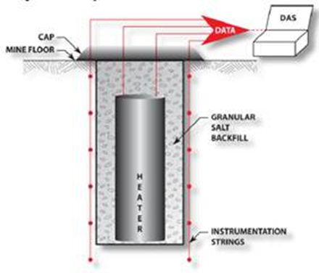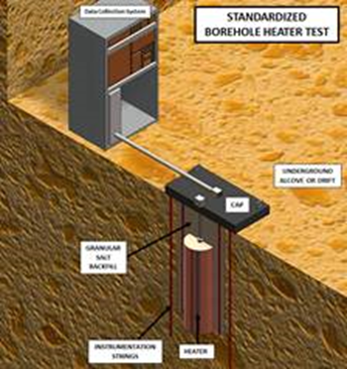

Figure 2‑1. Schematic of small-diameter borehole thermal test.

Examples of safety questions that can be addressed in the borehole heater tests include

* Does heat substantially change rock characteristics and evolution of the brine distribution/chemistry within intact/DRZ salt in such a way that post-closure performance would be impacted (rate of closure for example)?
* How closely do THMC models simulate the thermally-driven behavior of the mechanical, hydrological and chemical changes in the system, as well as the pre-heating processes in the system (i.e., can we predict the 2 years of *in situ* testing)?
* What are the chemical compositions of gasses and liquids sampled from around an actively heated region in contact with intact/DRZ salt?
* How well do borehole plugs perform in a heated experiment?
* Do uncertainties and inherent variability in salt formation mineralogy and brine composition lead to cases where acid gas formation becomes an important consideration?

A rough projection of schedule is provided in Figure 2-2.

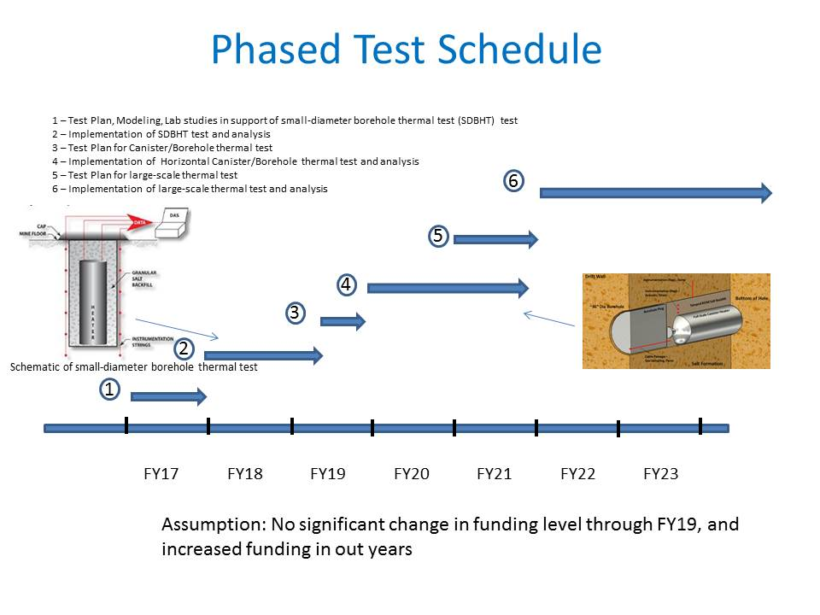

Figure 2‑2. Test Schedule.

Phil--More text re: schedule here?

# GRANULAR SALT RECONSOLIDATION

At the June 6th meeting a phased field-test campaign starting in FY17 was proposed to reconsolidate granular salt and assess first-order performance characteristics as functions of mixture percentages of salt, clay and moisture. The expected outcome provides the essential technical elements to revolutionize salt repository seals and operational concepts. This testing program is scalable from prototype, to intermediate-scale surface testing, to *in situ* demonstrations. This testing holds the potential to provide salt repository investigations a basis for operational panel closures that attain high performance characteristics early in a salt repository lifetime. This effort will help optimize construction methods and placement performance of shaft seal components, panel closures, and structural backfill for salt repositories.

## Brief Overview

In this section, we respond to a request by DOE-NE to scope a testing program of intermediate scale that can be conducted in 1-2 years and include components of surface testing that could be transferred to underground testing. Three phases will provide a time-and-cost efficient testing program by optimizing a test a matrix:

1. Scoping laboratory tests of end-member mixtures and evaluation
2. Above-ground testing at intermediate scale and evaluation
3. Optimized underground demonstration and evaluation

As with the borehole testing described in Section 2.0, reconsolidation testing has been the subject of previous DOE NE reports (Sevougian et al. 2013; Hansen et al. 2016). Reconsolidation optimization is a subject of intense international interest, as summarized in Hansen et al. (2016). Collaborators at the 6th US/German Workshop on Salt Repository Research, Design and Operation revisited possibilities for URF utilization. Break-out session discussions identified large-scale consolidation the highest priority field testing.

After the geologic formation itself, seal systems are the most important design element for prevention of migration of disposed nuclear waste to the accessible environment. Design, analysis and performance assessment of potential salt repositories require knowledge of mechanical and fluid transport properties of reconsolidating granular salt, which is normally expressed as permeability as a function of porosity. This work will address evolution of reconsolidating salt and determine how quickly various test mixtures attain desirable performance characteristics under variable conditions.

**To streamline investigations:**

* **First-order variables will be scoped in laboratory tests in FY2017.**
* **Concurrently in 2017, surface-based testing on an intermediate scale will be developed.**
* **Both surface-based test series will help optimize**

**underground testing when the opportunity arises.**

This test program can begin immediately and at modest cost. The first activity is development of a Test Plan in accord with prevailing QA requirements to ensure that the scientific activity is accomplished under suitable controlled conditions. Test Plans are approved prior to initiation of work and describe the scientific activity in sufficient detail to allow the test or experiment to be conducted. In these investigations, proven laboratory test techniques will hydrostatically compress lead-jacketed specimens at room temperature using the test rigs shown in Figure 3‑1. Scoping investigations target the proposed matrix provided in Table 3‑1. These scoping tests will define parameters for larger, intermediate-scale surface-based testing. Permeability measurements and forensic microscopy will assess the effectiveness and attendant consolidation mechanisms. Testing is estimated to cost $180K. A Test Plan nominally costs $25K to produce, review and activate. Forensics and reporting of the first phase will require 6 months and roughly $100K. Test information will then be available for maximal efficiency on intermediate-scale surface-based testing.

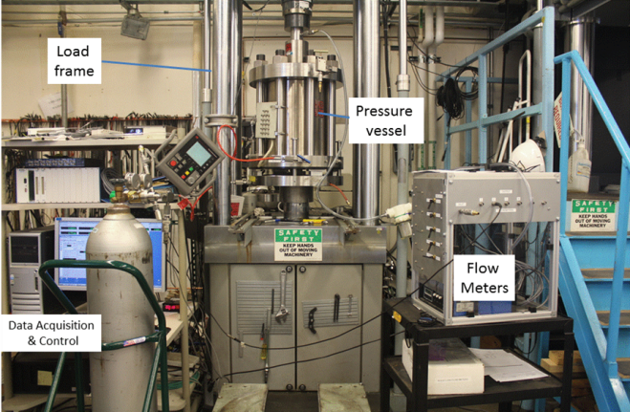

Figure 3‑1. Triaxial test apparatus for scoping experiments.

Table 3‑1. Nominal mixtures for Laboratory scoping tests

|  |  |  |  |
| --- | --- | --- | --- |
| **Test number** | **Salt %** | **Bentonite %** | **Moisture %** |
| 1 | 100 | NA | NA |
| 2 | 100 | NA | 1 |
| 3 | 90 | 10 | NA |
| 4 | ~90 | ~10 | 1 |
| 5 | 95 | 5 | NA |
| 6 | ~95 | ~5 | 1 |

After the consolidation admixtures are optimized as described above, Test Plans for surface-based intermediate-scale testing can be developed. All of this can be accomplished in FY17.

Implementation of surface-based intermediate-scale testing can be readily scaled to budget constraints in FY18. Transference of information and techniques from laboratory testing to intermediate scale testing anticipated to activate a cubic meter of material would be straightforward and mobile, if desired. Surface-based testing would require a reaction frame to substitute for the roof and floor of the salt mine. Commercial jacks with a requisite reaction frame vessel, such as shown in Figure 3‑2 (left), are readily available. A substantial vessel would contain the consolidating salt, such as shown in Figure 3‑2 (right). Transition to the underground may be an important consideration in the choice of jacks. Above ground testing and shakedown under ambient conditions are estimated to require 12 months and an estimated budget of $2.4M. The steps underlying this estimate are given in Section 3.2.

Less expensive alternatives can be made. These studies are fundamentally important to future salt repository seal systems, operations, and the modular build-and-close repository concept.

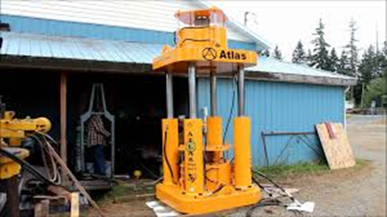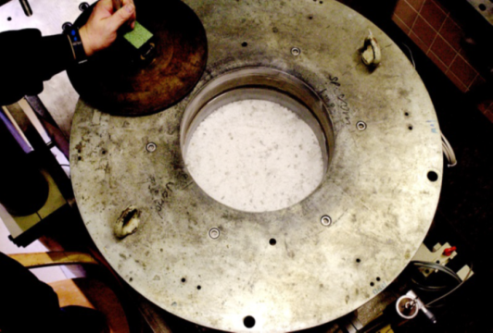

Figure 3‑2. Commercial jack system with integrated reaction frame.

Underground testing will benefit from preliminary scoping tests and above-ground intermediate scale testing. One concept for underground testing is illustrated in Figure 3‑3. A borehole will be filled to an appropriate level with a tailored backfill, as identified from surface testing. The *in situ* test matrix would include variables of moisture content and additives that might reasonably be applied in actual repository seal elements. Mixing protocol will follow procedures developed above ground and test material will be placed in the borehole with predetermined compaction to affect a desired density/porosity. Axial pressure would be applied by bracing a jacking system against the roof of the drift. As can be readily seen, this testing configuration constitutes a scaled-up version of laboratory oedometer tests. In the sketch below, existing jacks are considered for use and this option is under investigation. Total cost for intermediate-scale field testing is expected to be greater than surface based testing. Underground work would not be expected until FY2019, given prevailing assumptions of the June 6th meeting. It should be reiterated that international consensus supports large-scale consolidation as the highest priority field testing (Hansen et al. 2016).

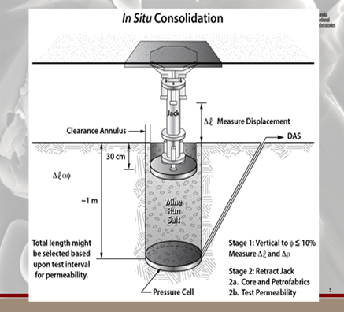

Figure 3‑3. Field-scale reconsolidation of granular salt.

## Discussion

The proposed series of tests is grounded on international consensus of need. The purpose is to evaluate granular salt reconsolidation as applied to seal systems for salt repositories. The outcome could transform salt repository concepts and licensing, while solving the national imperative of nuclear waste disposal.

International collaboration has helped develop concurrence on a research agenda. The licensing process, as noted previously, involves several different lines of reasoning in presentation of performance arguments. Technical information needs to be conveyed to stakeholders and regulators in a manner that simultaneously demonstrates the supporting information and aids comprehension of a nontechnical audience. Whereas some technical experts believe phenomena associated with crushed-salt reconsolidation are well constrained and supported by analogue examples, this view may not be held by other experts and informed lay personnel. The perception that salt reconsolidation processes and associated phenomena are imperfectly known is crucial to a license application for a salt repository. A regulatory authority will ultimately weigh various lines of evidence and decide the merit of performance arguments. By virtue of extensive international collaborative research, a few areas warranting further examination are

* Test scale: Testing time and space scales need to be reconciled with repository applications. Laboratory tests comprising the bulk of empirical evidence are principally small scale and short duration; whereas, the repository application involves meter-scale drifts and times ranging from years of operations to perhaps longer periods.
* Additives: Most backfill research and repository design has been concerned with use of run-of-mine crushed salt without additives, such as bentonite. Evidence suggests that performance characteristics could be improved with admixtures. Admixtures provide greater placement density and performance. This engineering achievement reduces uncertainty and perceived reliance on modeling.
* Low-porosity characteristics: Low porosity creates experimentally challenging conditions for permeability measurement. The fundamental transformation mechanisms that create low permeability could benefit from further laboratory study and analogue examples.

The spectrum of investigations is vast, ranging from laboratory experiments to natural and anthropogenic analogues. And despite a lingering uncertainty associated with modeling, a constitutive model that captures reconsolidation behavior is expected in the framework of licensing. Additional analogue studies are recommended. For example, naturally consolidating large salt piles and active deposition of salt sediments in the Dead Sea could provide insight into consolidation under low-stress conditions. The Backfilling and Sealing of Underground Repositories for Radioactive Waste in Salt (BAMBUS) experiment in the Asse mine has continued to consolidate under ambient conditions and collaboration continues on characterizing basic properties (Hansen 2016). In addition, the salt repository international community should continue to pursue relevant information from forth-coming projects involved with abandoning conventional mines.

Given these perceptions, a research path has been recommended that includes assessment of improvement in consolidation properties with additives, such as moisture and clay. The reason for further experimental work is illustrated in Figure 3‑4, which plots a significant amount of experimental consolidation data [Repoperm 2009; IfG 2012].

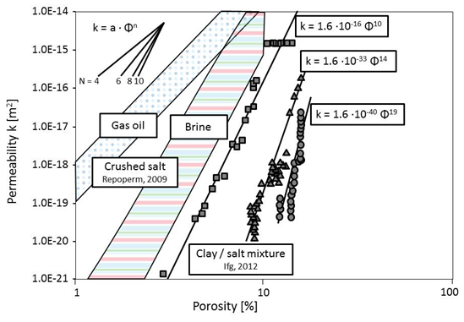

Figure 3‑4. Permeability-porosity datasets for crushed salt and mixtures.

Added moisture of less than one percent enhances reconsolidation appreciably, but what is the optimal moisture addition if the granular salt is mixed with clay? What are the underlying reasons for rapid permeability reduction with clay additives? The nature of testing fluids (brine or gas) and the resultant permeability/porosity relationships warrant further examination. If bentonite is added, the compacted backfill becomes tighter at relatively greater porosity. What are the consolidation processes by which this occurs?

**Large-scale *in situ* consolidation** pertains to most concepts of salt disposal. Reconsolidation of granular salt to low porosity and low permeability at field-scale application is prerequisite to affecting sealing functions. Disposal of heat-generating nuclear waste in salt is safeguarded by characteristics of the geologic formation and geotechnical barriers. Reconsolidation to a low porosity state exhibiting characteristics of undisturbed natural salt has been demonstrated in laboratory testing and can be inferred from analogues. At the scale of meters, which is the applicable scale for salt geotechnical barriers, there are no existing controlled experiments in which granular salt has been reconsolidated to low porosity. The proposed *in situ* tests provide a straightforward approach with conceivable variations to evaluate first-order consolidation parameters, such as moisture, temperature and additives. The phased testing proposal presented in previous text will go a long way toward building confidence in seal function properties of reconsolidating salt.

Mixing material for testing is expected to be straightforward, involving weights and measures commonly used in batching concrete with about the same data quality objectives. Remember, these demonstrations are a prelude to construction. They should be well defined to be sure, but extreme accuracy of mixture components is not anticipated. Mixing can be done in a conventional concrete mixer of convenient size. The test mixture components would include

* Run-of-mine granular salt
* Bentonite
* Moisture applied as mist

All components will be pre-weighed, mixed, and placed in the test vessel or borehole. Compaction effort can be exerted to level the surface or create a desired initial density. With practice, assembly of a test specimen should be easy and fast. Assembly into the axial testing alignment will depend on the choice of actuator. Consolidation will proceed at laboratory rates, at least initially, to assess first-order effects.

Application of heat is an additional demonstration parameter, though it is secondary because operational period panel closures would be located down-drift from the disposal areas and would not experience a significant thermal pulse. Nonetheless, surface testing could readily accommodate attachment of a heating blanket on the thick-walled cylinder, so surface testing of thermal conditions would be possible. Underground, application of heat would a little more challenging.

A rough-order-of-magnitude cost estimate was requested to accompany this proposed testing. Therefore, a list of assumptions needs to precede time and cost estimates.

Assumptions for surface-based intermediate-scale consolidation testing are

* Testing to be done in Carlsbad.
* Includes purchase of instrumentation for displacement, load, data acquisition.
* Post-compaction testing will involve obtaining a dry-drilled core for lab forensics and testing.
* One test at a time on the surface.
* Temperature testing only after first matrix of mixtures is tested at ambient conditions.
* Quality assurance procedures will be applied.
* Initial loading cycles will be relatively rapid, although testing circumstances should be robust enough that interruptions will not adversely affect results. A test may be set up on day one, tested on day two, and cored on day three.
* Mixtures will be pre-determined and unchanged during testing.
* Initial test matrix will be determined from scoping laboratory testing.
* In the underground, new boreholes will be used for each test.
* Underground tests would need to be 2 meters deep to situate the bottom of the hole below the DRZ—if permeability testing is to be made *in situ*.

There are many additional details that may add cost to the estimates provided below, but the surface testing is eminently doable.

Information provided below is to provide rough-order-of-magnitude estimates of time and costs. Agreement to pursue the test concept from start to finish must be obtained.

Ideas of costs and time are

* Test Plan development: $40k 2 months
* Load frame design and fabrication or purchase: $40k 1 month
* Assembly: $40K 1 month
* Engineered safety and readiness review: $60k 1 month
* Shakedown testing and data acquisition system: $100k 2 months
* First series of 3-salt/bentonite tests: $200k 2 months
* Second series of 3-salt/bentonite/water: $200k 2 months
* Third series of 3-elevated temperature tests (optional): $300k 3 months
* Testing and evaluation of data: $50k/month (simultaneous activity)
* Forensic petrofabrics and lab testing: $50k/month (simultaneous activity)
* Records and reporting: $40k/month (simultaneous activity)
* Publication: $40k 1 month at end
* Above ground testing and shakedown (ambient): 12 months $2.4M.
* Above ground testing with elevated temperature would increase cost and is likely unnecessary to geotechnical seal application.

Circumstances that may be influence conduct of the above ground testing revolve around the loading system chosen, load frame modification at a reasonable cost, attaining 12 inches of stroke, environment, safety and health issues, and temperature testing.

## Underground Testing

Transfer to the underground adds some degrees of difficulty. However, by conducting the surface tests, testing in the underground can be optimized and therefore underground time and cost minimized. Important variables can be selected from surface tests. For the purpose of estimations here, we must assume underground access will be available and underground staff provided at sufficient levels to support a 12-month drilling and testing program. The expectation is that 40 hours per week of access and support will be provided for underground testing.

Equipment for underground drilling of large-diameter holes needs to be obtained. The length of time to prepare for underground work is much longer than before the WIPP shut down and work-days are shorter. All resources at the WIPP site are geared toward recovery/restart in a highly regulated work environment. Underground testing will require six months minimum to work through all aspects of the safety program and create something that is ready for construction and testing. Procurement of services and construction of facility items take significant time. Below are rough estimates for a list of activities to conduct intermediate scale consolidation tests in the WIPP. Some of the preparatory training and purchases can be accomplished while surface work progresses.

* Site underground operations will need to procure a drill and bits capable of drilling 1-meter diameter holes up to depths of 2 meters below the floor. $100k 4 months
* Sandia’s current safety culture including 1) engineered safety, 2) pressure safety, 3) Job Safety Analysis, 4) electrical safety, 5) subcontractor safety plans, 6) Preliminary Hazards Assessment, 7) National Environmental Policy Act, 8) Technical Work Documents. $500k 6 months
* Site underground operations department will need to estimate the man-hours and cost associated with this level of support. $1M 12 months.
* Transfer load system to the underground $50k 1 month
* Operational readiness review, safety, training, QA $250k 3 months
* Underground set up and preparations $150k 3 months
* Conduct consolidation tests: $100k/test stage each 1 month $600K 6 months
* Forensics and performance testing: $100k/test stage each 1 month $600k 6 months
* Records and reporting: $40k/month (simultaneous activity)
* Publication: $40k 1 month at end
* Total for underground testing: $3.77M 14 months (ambient only)

# SHEAR TESTING

At the June 6th 2016 meeting a phased testing program concentrating on properties of layers and discontinuities was presented by Frank Hansen. The supporting material was developed by Steven R. Sobolik, SNL, co-author of this report. Starting in FY17, this phased testing program will measure, evaluate, and quantify effects of shear displacement along bedding interfaces. Extensive collaborations with German salt repository researchers have identified four key research areas to better understand the behavior of salt for radioactive waste repositories. Shear testing of seams was identified (once again) as an important, but missing, component of the constitutive models for salt, especially bedded salt.

This subject area includes the influence of nonhomogeneities, which are represented explicitly in WIPP modeling and would be included in any future bedded salt repository study. The expected outcome of shear tests includes improved understanding of shear stresses and strains on bedding interfaces that can be translated to current geomechanical and performance assessment models for repository performance.

This proposal was prepared in response to a request by DOE NE to scope a testing program of intermediate scale that can be conducted in a 1- to 2-year time frame and include components of surface testing that could be transferred to underground testing. Three phases will provide a time-and-cost efficient testing program by optimizing a test a matrix:

1. Scoping laboratory tests of shear across interfaces using controlled samples (blocks of different materials such as anhydrite and halite) and samples obtained from the field (halite with included clay seam) – FY17.
2. Numerical modeling of laboratory results to develop appropriate shear friction/fracture models – FY17.
3. Underground tests in alcove wall with clay seam or similar interface – FY18.

There are essentially no *in situ* measurement data characterizing shear strength of an interface in salt and resulting effects of interface displacement and permeability. Munson & Matalucci (1983) proposed an *in situ* test with direct shear across a clay seam at WIPP. This proposed test never occurred. The concept involved isolating a 1-by-1-m block in a wall containing a representative clay seam by cutting around it. Flatjacks were proposed to be installed in slots cut around the block to apply shear and normal stresses. Displacements along and across the seam would be measured as function of applied stress. The need for this type of information has been recognized for many years. In the absence of empirical information modeling implements engineering estimates with their inherent uncertainties.

Some laboratory and computational investigations have evaluated the slip along interfaces under several different stress environments. Minkley & Mühlbauer (2007) performed direct shear laboratory tests on carnallite and salt blocks under varying normal and shear loads and shear velocities, as shown in Figure 4‑1. With these data, they developed a shear model for interfaces that accounts for both velocity-dependent and displacement-dependent shear softening mechanisms. The plots in Figure 4‑1, taken from Minkley & Mühlbauer (2007), show the evolution of shear stress as a function of shear displacement for two different shear velocities.

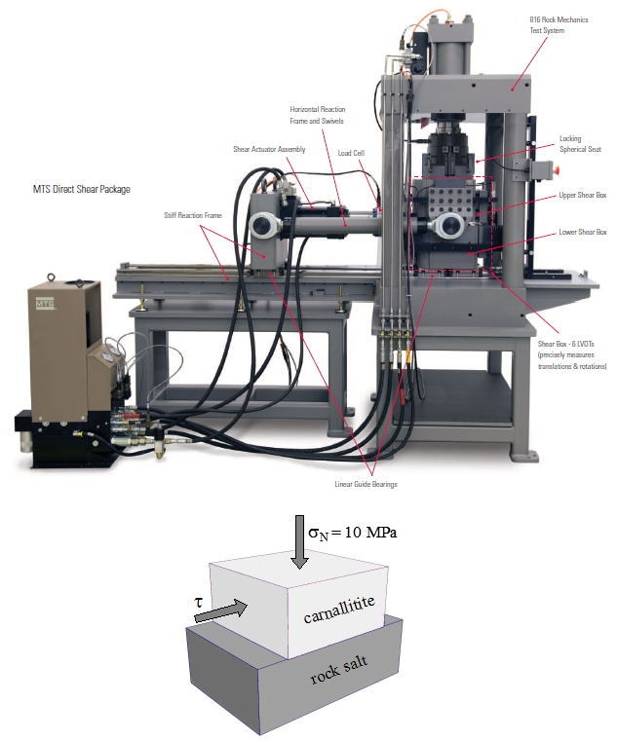 

Figure 4‑1. Direct shear test setup; Shear stress vs. displacement for different shear velocities (Photograph of MTS direct shear machine from MTS website).

There are three phases to this test suite. The first phase consists of a series of laboratory direct shear tests on several samples of materials typical of WIPP emplacement drifts. Some test samples shall be control samples – machined blocks of halite and an appropriate other material such as anhydrite, clay, or polyhalite. These tests will be conducted at several normal and shear loads up to expected *in situ* stress conditions, and at multiple shear velocities. From these tests, the second phase will be the development of a shear friction model in the same manner as that in Minkley & Mühlbauer (2007). For the completion of the laboratory phase, several test samples gathered from a field location containing a clay seam or otherwise distinct bedding discontinuity will be tested in the laboratory, with pre- and post-test model predictions and calibration.

For these laboratory tests to approximate *in situ* overburden stress conditions, normal stresses of 1000-3000 psi are required. To perform tests at these stress levels, it is recommended that laboratory tests be performed using the RESPEC direct shear machine. It has an axial and shear load capacity of 30,000 lb each. Samples may be as large a 6” cubes. The shear velocities range from a minimum of 0.010-0.015 in/min (0.004-0.006 mm/sec) to a maximum of 0.2 in/min (0.083 mm/sec). As seen in Figure 4‑1, the shear displacement is applied to the top box. After these tests have been performed, intact salt samples that include a distinct interface, such as a clay seam, will be obtained from field locations and tested. The number of shear tests that can be performed is limited primarily by the number of samples that can be gathered and prepared.

The primary result of these direct shear tests will be data from which shear/friction models will be developed; these models will be evaluated using the results of *in situ* shear tests planned for FY18, and then provided for inclusion in the WIPP models. In addition, other laboratory testing options including torsion tests and permeability tests of the field samples may be considered if appropriate test procedures and direct input into repository models can be demonstrated. The laboratory costs of the first phase of tests will depend on the number of samples obtained and tested, but is not expected to exceed $500K. The costs of the modeling corresponding to the second phase are expected to be no more than 0.25 FTE, or $120K.

The third phase of this test suite is the implementation of *in situ* direct shear tests in FY18. For the design of the *in situ* test, it is important that the laboratory and *in situ* tests should as much as possible measure the same processes and variables, just at different scales. After much discussion with WIPP modelers and colleagues in the salt repository community, it was decided that control of the normal and shear loads is required to provide information valuable for the modeling of the emplacement drift. Therefore, the following design of an alcove with a test pillar was developed:

* An alcove with a “room divider” pillar would be cut out of a drift, as illustrated in Figure 4‑2. The alcove would be chosen in a location with a prominent horizontal clay seam or similar feature in the rib. The pillar would have three free surfaces with the horizontal clay seam in the middle. Figure 4‑3 is an actual test room of this configuration in Busted Butte tuff.

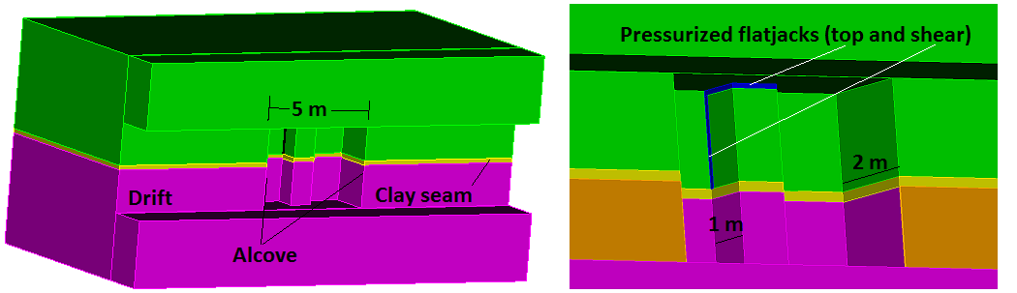

Figure 4‑2. Conceptual design of *in situ* test alcove, with flatjack locations.

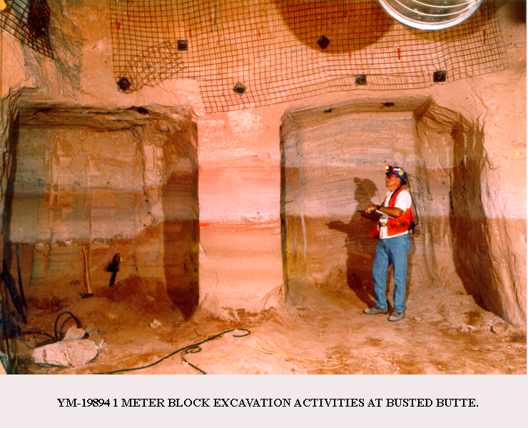

Figure 4‑3. Isolated test pillar

* Slots would be cut in the top of the pillar and the back of the top portion of the pillar. Pressurized flatjacks would be installed in these slots; the top flatjack applies a known axial or normal stress, and the back flatjack applies the shear stress, thus replicating a direct shear test. Figure 4‑4 is a photograph of a pressurized flatjack used for a pressurized slot test performed at Yucca Mountain. The flatjacks would be instrumented with rotating linear potentiometers gages (4 per flat-jack, 0-5 cm range) to measure displacements between the two load-bearing platens.

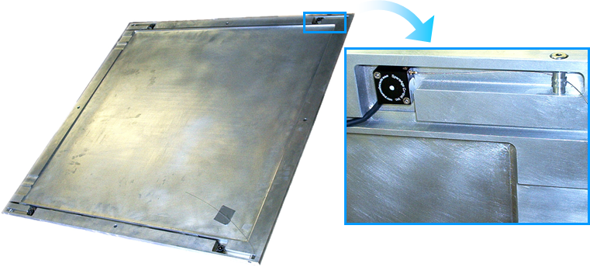

Figure 4‑4. Pressurized flatjack instrumented with rotating potentiometer.

* Instrumentation on the pillar would include LVDTs, yo-yo displacement gages, load cells, video displacement monitoring, and pressure transducers.

The cost of the *in situ* experiment would include development of a Test Plan with appropriate technical and environment, safety and health information; construction of the test alcove and slots; pressurized flatjacks and other instrumentation equipment; calibration and installation of the instrumentation and data collections systems; and performance of the test. The cost of this test will be better defined after details of the test design are developed, but a cost in the neighborhood of $1M can be expected.

# CONCLUDING REMARKS

Salt testing at an intermediate scale was the discussion theme of a special meeting arranged by DOE NE at their Las Vegas Nevada offices on June 6, 2016. Proposed testing was described and discussed and this report summarizes the presentation material, including perceived justification for the various tests. Guidelines for proposals included reasonable cost, ability to perform meaningful testing in 2017, and scalability to field settings.

Three primary proposals were discussed in detail:

1. Small-diameter borehole field test,
2. Reconsolidation of granular salt, and
3. Shear strength and deformation along discontinuities.

Phil--Brief summary of merits of small-diameter heater test here.

Reconsolidation of granular salt has the potential to reshape salt repository operations, licensing, performance assessment, and safety. Second only to the geologic formation itself, reconsolidation optimization is a subject of intense international interest and identified as the highest priority field testing.

Similarly, after many years of benchmarking field tests, the greatest mechanical uncertainties have been identified. Shear behavior of contact zones, clay layers, and horizontal heterogeneities is one of the untested *in situ* characteristics of bedded salt. Therefore, a phased testing approach to reduce uncertainty of shear behavior remains a high priority for repositories in bedded salt.

# REFERENCES

Caporuscio, et al. 2013.

Czaikowski, O., K. Wieczorek, and K.-P. Kröhn. 2012. *Compaction of Salt Backfill – New Experiments and Numerical Modeling*. FKZ 02 E 10740 (BMWi). The Mechanical Behavior of Salt VII: Proceedings of the 7th Conference (MECASALT VII). Paris.

Droste. 2003.

Hansen, F.D. 2016. *Characterization of Reconsolidated Crushed Salt from the BAMBUS Site*. SAND2016-2794. Sandia National Laboratories, Albuquerque NM.

Hansen, F.D. and Thompson, T.W. 2002. *Effective Permeability of the Redesigned Panel Closure System*. Memorandum to Paul E. Shoemaker. ERMS 523476. Sandia National Laboratories, Albuquerque, NM.

Hansen, F.D. and C.D. Leigh. 2011. *Salt Disposal of Heat-Generating Nuclear Waste*. SAND2011-0161, Sandia National Laboratories Albuquerque New Mexico.

Hansen, F.D. et al. 2013. *Proceedings of the 4th US/German Workshop on Salt Repository Research, Design, and Operation*. FCRD-UFRD-2014-00335. SAND2013-10592P. Sandia National Laboratories, Albuquerque, NM.

Hansen, F.D. et al. 2015. *Proceedings of the 5th US/German Workshop on Salt Repository Research, Design, and Operation*. FCRD-UFRD-2015-00514. SAND2015-0500. Sandia National Laboratories, Albuquerque, NM.

Hansen, F.D. et al. 2016 *Proceedings of the 6th US/German Workshop on Salt Repository Research, Design, and Operation*. FCRD-UFRD-2016-00069. SAND2016-0194R. Sandia National Laboratories, Albuquerque, NM.

IfG. 2012. *Laboruntersuchungen am Gemisch Schnittsalz - Friedländer Ton*. Institut für Gebirgsmechanik GmbH, Leipzig.

ISIBEL. 2010). <http://www.eurosafeforum.org/userfiles/>

Krumhausl. 1991.

Kuhlman, K.L. and B. Malama. 2013. *Brine Flow in Heated Geologic Salt*. SAND2013-1944. Sandia National Laboratories, Albuquerque, New Mexico.

Minkley, W. and J. Mühlbauer. 2007. *Constitutive models to describe the mechanical behavior of salt rocks and the imbedded weakened planes.* Wallner, M., K-H Lux, W. Minkley, H.R. Hardy, eds. The Mechanical Behavior of Salt: Understanding of THMC Processes in Salt. Taylor & Francis/Balkema, Leiden, The Netherlands.

Munson, D.E., Hoag, D.L., Blankenship, D.A., DeYonge, W.F., Schiermeister, D.M., Jones, R.L., and G.T. Baird. 1997*. Instrumentation of the The4rmal/Structural Interactions in situ Tests at the Waste Isolation Pilot Plant (WIPP).* SAND87-2686. Sandia National Laboratories, Albuquerque NM.

Munson, D.E. and Matalucci, R.V. 1986. *Planning, Developing, and Fielding of Thermal/Structural Interactions in situ Tests for the Waste Isolation Pilot Plant (WIPP).* SAND83-2048. Sandia National Laboratories, Albuquerque NM.

REPOPERM. 2009. *Restporosität und permeabilität von kompaktierendem Salzgrus-Versatz* (Residual porosity and permeability of compacting granular salt backfill). GRS-254. Gesellschaft für Anlagen-und Reaktorsicherheit (GRS) mbH.

Rudqvist, J. 2015.

Sevougian, S.D., MacKinnon, R.J., Robinson, B.A., Leigh, C.D., and Weaver, D.J. 2013. *RD&D Study Plan for Advancement of Science and Engineering supporting Geologic Disposal in Bedded Salt – March 2013 Workshop Outcomes*. FCRD-UFD-2013-000161. SAND2013-4386P.

Stauffer, P.H., Jordan, A.B. Weaver, D.J., Caporuscio, F.A., Ten Cate, J.A., Boukhalfa, H., Robinson, B.A., Sassani, D.C., Kuhlman, K.L., Hardin, E.L., Sevougian, S.D., MacKinnon, R.J., Wu, Y., Daley, T.A., Freifeld, B.M., Cook, P.J., Rutqvist, J., and Birkholzer, J.T. 2015. *Test Proposal Document for Phased Field Thermal Testing in Salt*. FCRD-UFD-2015-000077. LA-UR-15-23154.

Appendix A

**Draft Scopes of Work for FY17 Activities to Support the Generic Repository Investigations Program in Salt**

*Single Canister Thermal Testing in Salt: $550K (LANL - $325K, SNL - $100K, LBNL - $100K, CBFO/NWP - $25K + in-kind commitments of approximately $550K)*

Scope: In collaboration with DO-EM, which will install a single full-size heated canister in the underground at WIPP to test operability and heater power supply systems in in-situ conditions, this work will use the opportunity to further the development and testing of key instrumentation suites for use in future thermal testing programs. Additionally, data from this experiment will reduce uncertainty in our understanding of the behavior of a heated canister under a Run-of-Mine salt pile and provide vital checks on numerical simulations.

Experiments performed in this configuration will provide valuable new information on RoM backfill in the presence of in-situ temperatures, pressures, and gas/liquid migration with a full-size heated canister. This test will also allow in-situ testing of instrumentation that has been developed by LBNL, LANL, and SNL as part of the DOE-NE UFD project. At a minimum, there will be thermocouples and/or RTDs, humidity probes, moisture sensors, electrical resistivity probes or fiber optic temperature devices, the ability to sample gas within the RoM salt, and reactive coupons. Additional instruments/tests could be added as funding and time allow.

This test will be a joint collaboration between DOE-NE and DOE-EM. The canister (10-ft length by 2-ft diameter) has already been constructed and tested to 1500 W over the past two years. DOE-EM has agreed to provide a niche in the newly mined thermal testing research area of WIPP for testing in the underground, access to run of mine salt, power run to the test location, underground test coordination, data collection, and access to WIPP, including training and other logistics. The DOE-NE contribution to this test will be test planning, instrumentation, implementation, and analysis. This provides a rare opportunity to design and test instrumentation that will be needed for any future in-situ thermal test. Additionally, the same configuration and instrumentation can provide insights into the behavior of intact and RoM salt and brine under intermediate scale conditions.

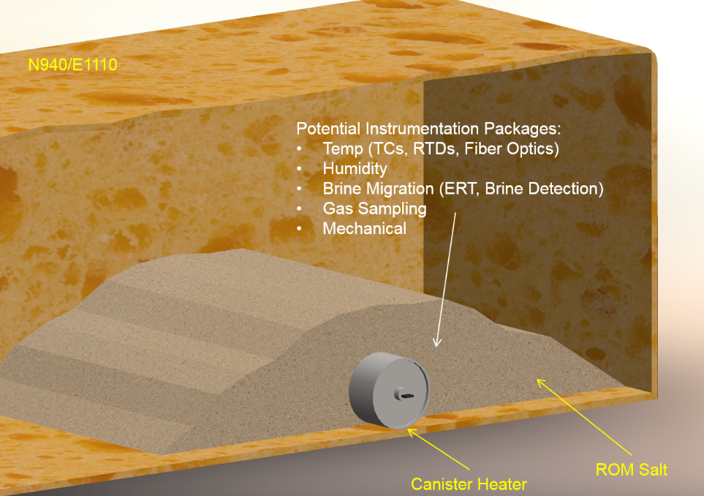

Budget:

* DOE-EM *CBFO/NWP* In-Kind Contribution:
  + Access to WIPP Underground and Test Niche, Canister Heater Install, Power, Cabling, Instrument Installation and Data Collection Support, Training, Test Coordination, Work Control, and Infrastructure Support = ~$550K
* DOE-NE LANL:
  + Test Planning and Modeling = $150K
  + Gas Sampling, Temperature, Moisture (leaf wetness, water content reflectometers, water matric potential sensors), Humidity Instrumentation = $150K
  + Data Collection = $25K
* DOE-NE SNL:
  + Room/Niche Closure Gage, Salt Pile Settling Gages, and Analysis= $100K
* DOE-NE LBNL:
  + Fiber Optic Temperature Monitoring and/or ERT = $100K
* DOE-NE CBFO/NWP
  + Support for field testing needs above and beyond agreed-upon consumables and labor. (e.g., brattice bulkhead to maintain conditions, extra cabling, and special lighting). = $25K

The streamlined budget described above is designed to begin a new underground testing program while staying within current DOE-NE budget projections. The scope of this effort can readily be expanded to include more instrumentation and analysis if additional funds become available.

Schedule:

* Approximate duration from Start of Activity to Heater Start. Schedule does not show modeling or analysis tasks.

